**Tracking Data Analysis**

European collaborator Mate has developed a tracking software which records data about dueling behaviors in *Harpegnathos Saltator* colonies. The goal of this project is to evaluate the efficacy of his software in comparison to human observers. Does the software pick up too many interactions (too sensitive), or not enough (not sensitive enough)? What is the correlation between human observations and Mate’s observations?

**Methods**

In order to evaluate the sensitivity of Mate’s tracking software, I need to compare equivalent data sets (i.e. data collected across the same time period). Mate’s software collected dueling data throughout entire video files while human observers only collected 1 minute of dueling data. In the name of efficiency, we will not observe full video files; the one-minute sample per hour should be representative of the entire video.

Mate’s tracking data will be cleaned and reinterpreted to the same format of the human observer data as well (presence or absence of dueling for each individual in each hour, rather than # of observed duels) for each different colony size. To do this, for each video file observed by humans, I will search Mate’s data for recorded duels in the same video file and populate a spreadsheet with the duels that humans observed and those that Mate observed. I will then combine the data for each video into one larger data set containing every video observed for each colony size. This data can be used to create a 2x2 contingency table which shows the frequency of each possibility: the human and the software agree that an ant has dueled, the human and the software agree that an ant has not dueled, the human believes an ant dueled and the computer does not (false negative), and the human does not believe an ant has dueled while the computer does (false positive). These tables will be generated for each group size and will be useful in determining the accuracy of the software across colony sizes.

In addition to the human and software collected presence absence data, I will also clean Mate’s data to include DuelNumber and DuelLength. This is essentially the same process mentioned above, except I will populate the spreadsheet with DuelNumber and DuelLength rather than presence/absence data. These categories have not been explicitly defined yet, but I can reasonably assume that DuelNumber represents either the number of discrete dueling events (i.e. two ants start dueling, stop, then start again is a DuelNumber of 2) or the number of approach/avoidances the software observes. DuelLength likely represents the time (the number of frames or seconds) an ant is recorded dueling for. These metrics, as well as the presence/absence data, will be summed for each ant across the entire recording period for each group, and then divided by the sum of total behaviors for all ants across the entire recording period for each group () .This provides us with a distribution of relative frequency of dueling for each different metric. I hope to see that these distributions are statistically identical; this would imply that Mate’s tracking software is sufficiently accurate and sensitive.

Additionally, I will create time-series plots using both human and Mate’s data. I will sum the number of times each ant is recorded dueling in each day, one sum for each data source. For each ant, I will graph its dueling behavior over time (days on x-axis, dueling sum on y-axis) for both data sets. The correlation between these two lines should reveal effective Mate’s tracking software is (higher correlation = more effective).

**Tracking Data Analysis – Preliminary Results**

**60W – SAFC20A Group:**

**Observation Contingency Table – 60W_SAFC20A**

|  |  |  |  |
| --- | --- | --- | --- |
|  | Tracking Software Presence/Absence Results | | |
| Human Presence/Absence Results |  | 0 (no duel observed) | 1 (duel observed) |
| 0 (no duel observed) | 4150 | 465 |
| 1 (duel observed) | 24 | 581 |

Figure 1: Contingency table showing agreements and discrepancies between human observers and tracking software. A count at (1,0) represents a false positive – The tracking software observed a duel where a human did not. Conversely, a count at (0,1) represents a false negative – A human observed a duel where the tracking software did not. Since humans only observe 1 randomly-selected minute of footage per hour while the software observes the full amount of time filmed, false positives are to be expected. False negatives are more indicative of flaws in the software. This data spans the full unstable period which humans sub-sampled 1 randomly selected minute each hour (**need to write a script to count # of hours observed). Mate’s tracking data was cleaned and compared with human observation data as presence/absence data. Agreements and discrepancies were summed across the entire filming period to populate this table.

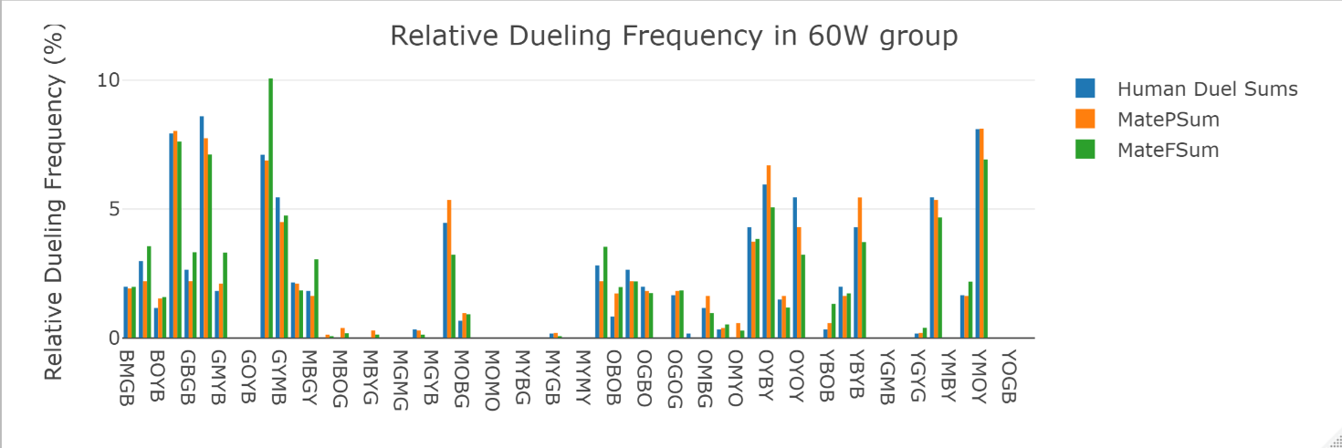

Figure 2: This graph compares relative dueling frequencies for each ant by 3 different methods. “Human Duel Sums” represents presence/absence data collected by human observers. “MatePSum” represents presence/absence data collected by Mate’s tracking software. “MateFSum” represents the DuelNumber data collected by Mate’s tracking software (I’m not sure exactly what this metric represents. It is likely the number of back and forth motions observed by the software). See methods for a description of how the relative frequencies were calculated.

**60W Dueling Sums Per Day**

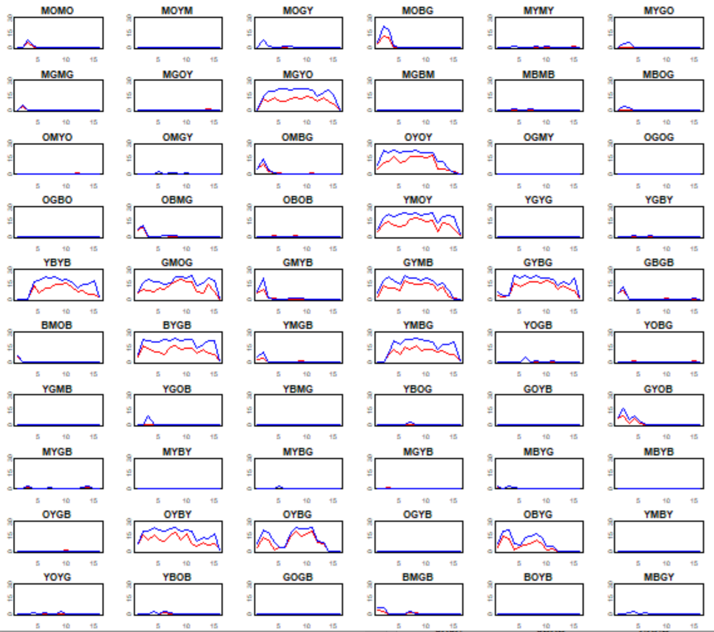

Red: Human observations; Blue: Mate’s observations. Y-axis = dueling sum, X-axis = day (1-6). Star = Gamergate

**30W – F102 Group:**

**Observation Contingency Table – 30W_F102 Group**

|  |  |  |  |
| --- | --- | --- | --- |
|  | Tracking Software Presence/Absence Results | | |
| Human Presence/Absence Results |  | 0 (no duel observed) | 1 (duel observed) |
| 0 (no duel observed) | 797 | 175 |
| 1 (duel observed) | 7 | 161 |

Figure 3: Contingency table showing agreements and discrepancies between human observers and tracking software for the 30W_F102 group. See the caption under Fig.1 for explanation.

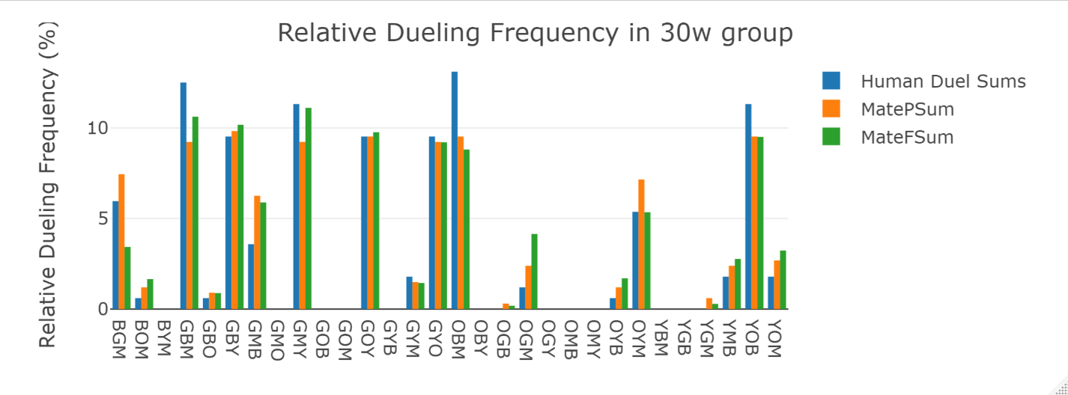

Figure 4: Distribution of relative dueling frequency in the 30W_F102 group. See caption under Fig. 2 for explanation.

**30W F102 Dueling Sums Per Day**

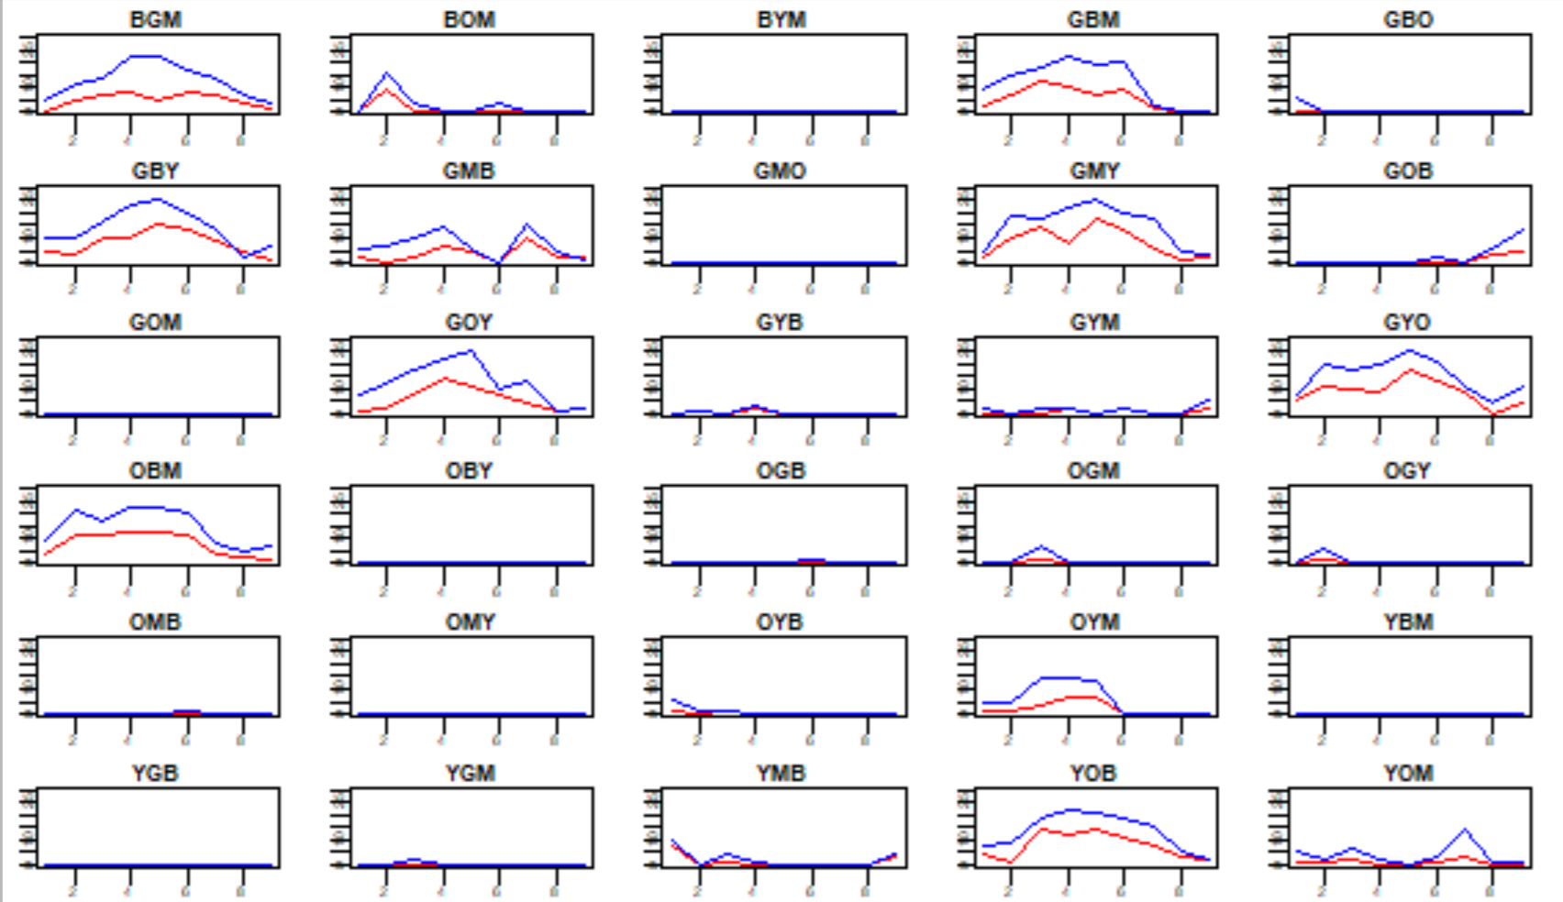

Red: Human observations; Blue: Mate’s observations. Y-axis = dueling sum, X-axis = day (1-9)

**Gamergate observations are potentially incomplete. Will likely make more sense with more data

**30W – 47BC Group:**

**Observation Contingency Table – 30W_47BC Group**

|  |  |  |  |
| --- | --- | --- | --- |
|  | Tracking Software Presence/Absence Results | | |
| Human Presence/Absence Results |  | 0 (no duel observed) | 1 (duel observed) |
| 0 (no duel observed) | 1103 | 136 |
| 1 (duel observed) | 0 | 201 |

Figure 5: Contingency table showing agreements and discrepancies between human observers and tracking software for the 30W_47BC group. See the caption under Fig.1 for explanation.

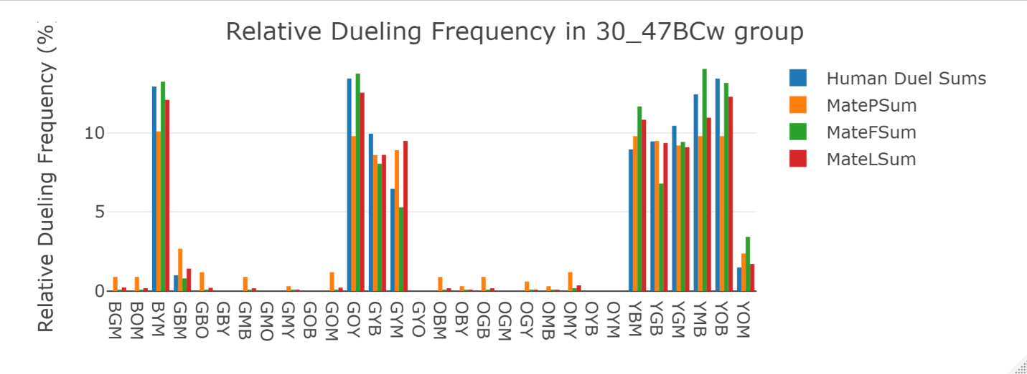

Figure 6: Distribution of relative dueling frequency in the 30W_47BC group. See caption under Fig. 2 for explanation. This graph has an added metric, MateLSum. It represents the relative length of duels recorded by Mate’s software (likely represents the # of frames ants are recorded dueling, but this has not been clarified). *If this is a useful metric for comparison, I will redo the graphs for the other groups as well.*

**30W 47BC – Dueling Sums per Day**

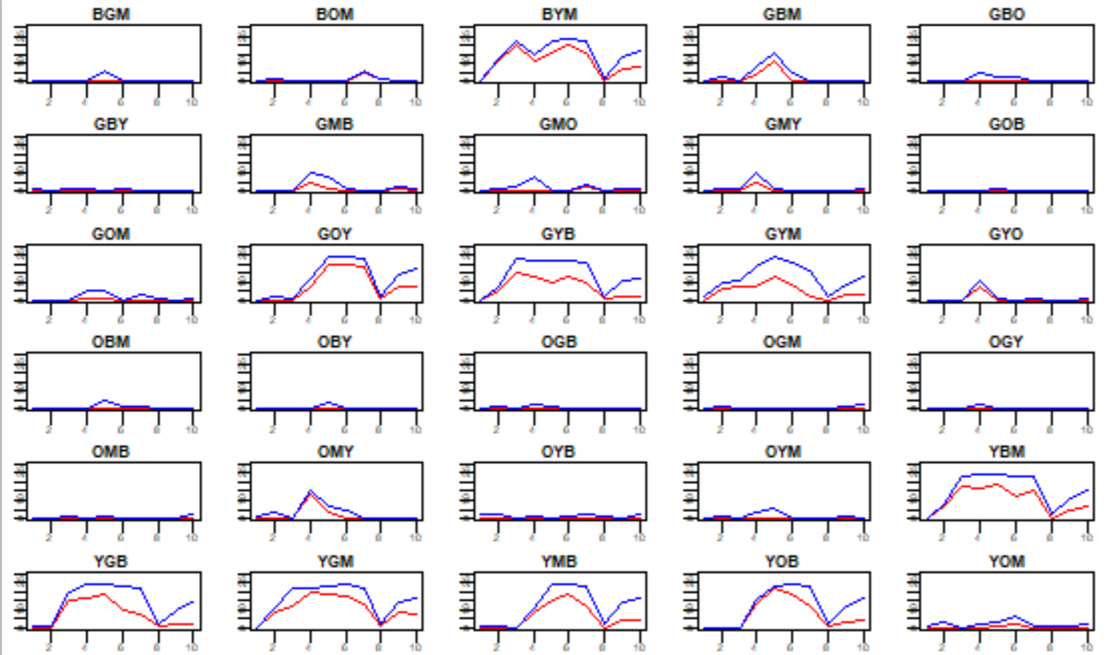

Red: Human observations; Blue: Mate’s observations. Y-axis = dueling sum, X-axis = day (1-4)

**15W_49B1 Group:**

**Observation Contingency Table – 15W_49B1 Group**

|  |  |  |  |
| --- | --- | --- | --- |
|  | Tracking Software Presence/Absence Results | | |
| Human Presence/Absence Results |  | 0 (no duel observed) | 1 (duel observed) |
| 0 (no duel observed) | 548 | 44 |
| 1 (duel observed) | 10 | 28 |

Figure 7: Contingency table showing agreements and discrepancies between human observers and tracking software for the 15W_49B1 group. See the caption under Fig.1 for explanation.

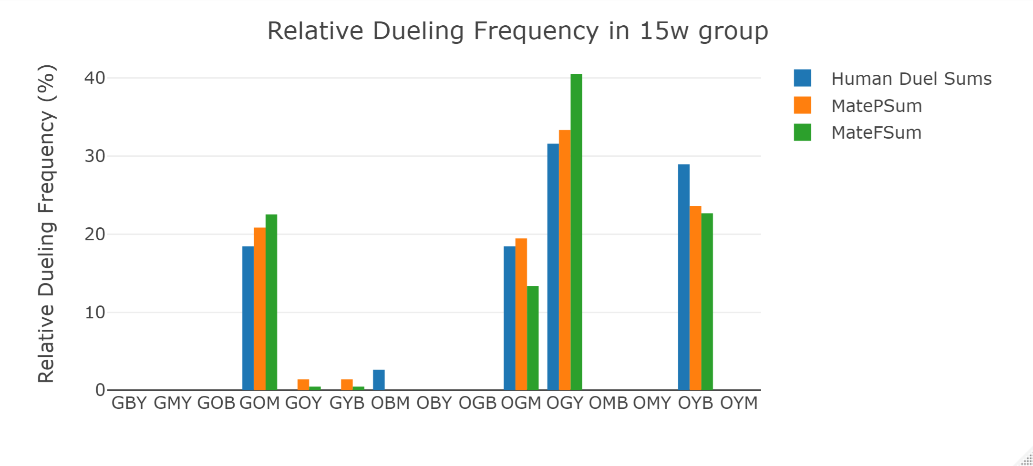

Figure 8: Distribution of relative dueling frequency in the 15W_49B1. See caption under Fig. 2 for explanation.

**15W – Dueling sums per day**

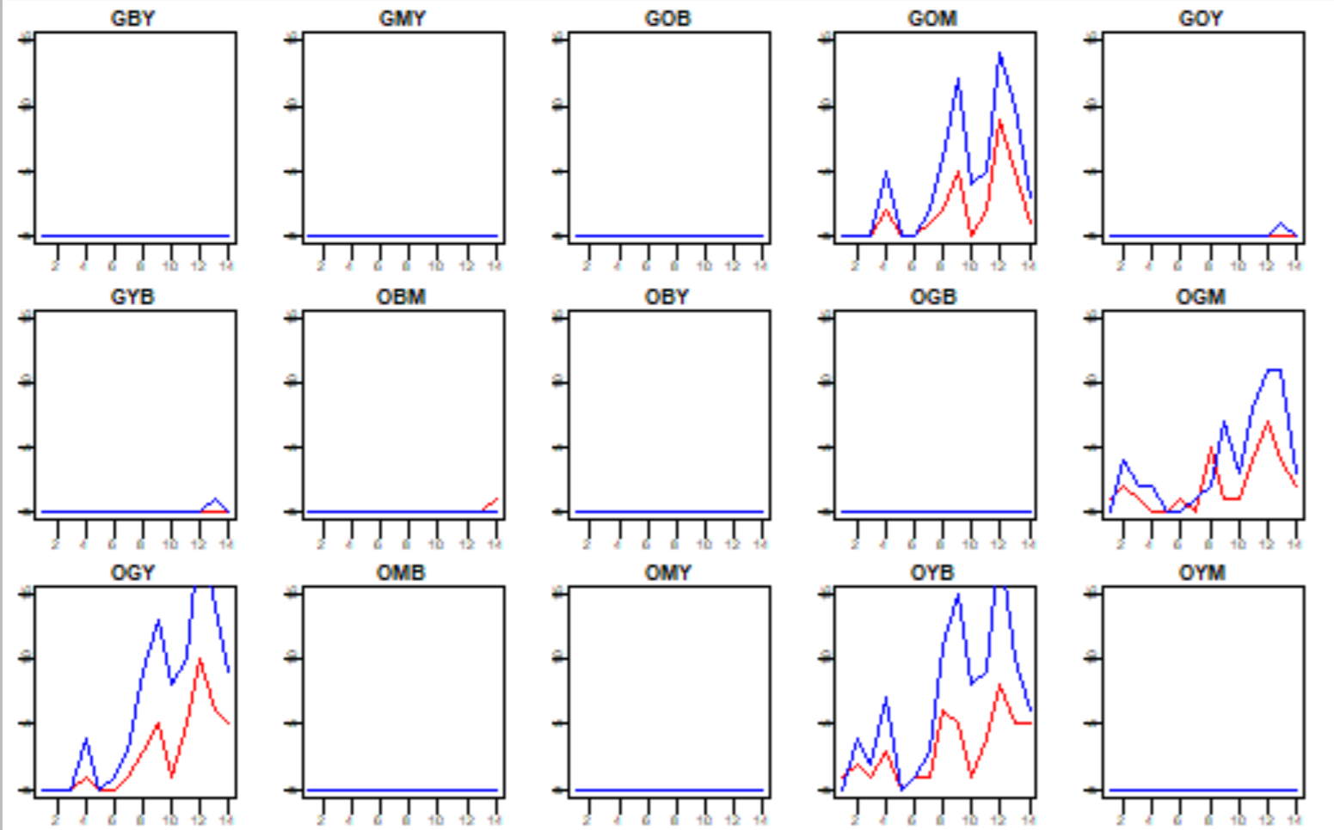

Red: Human observations; Blue: Mate’s observations. Y-axis = dueling sum, X-axis = day (1-3)